# Main page

The main image in carousel will be same as shown in elsaviour and can have the HTML over lapping like elsaviour. Provide us the CSS for that.

In the first page there is about GRD Journals which will have the introduction text in 60 to 70 words and will be provided by us,

Upon clicking the “Read More” Button. It will be redirected to the page showed here.

<http://preview.oklerthemes.com/porto/5.1.0/demo-medical-about-us.html>

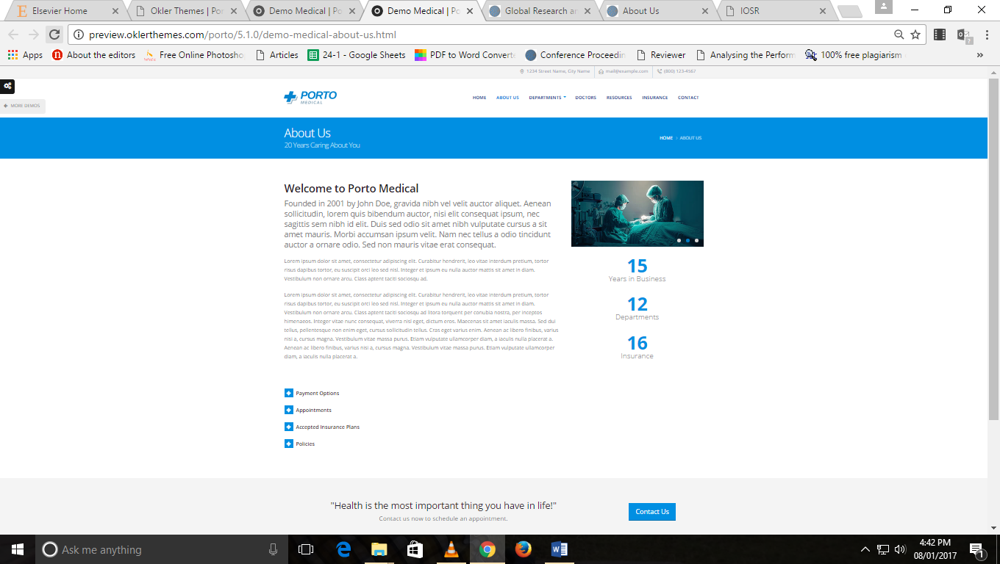This section will have the text provided by us.

There will be 4 counters down there.

1. <<No>> issues published
2. <<No>> articles received
3. <<No>> articles published
4. <<No>> Reviewers
5. <<No>> authors have submitted their work in GRD

Our Journals:

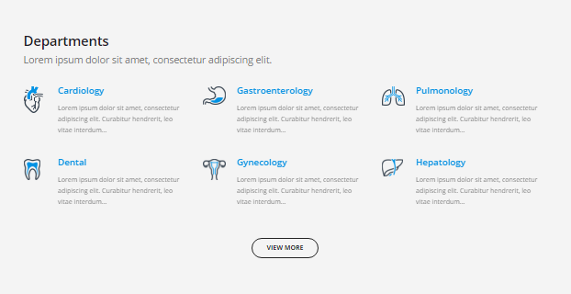

This part will be replaced by **our Journals** section mentioned in mock up.

This will be carousel. Which we have sent in mock up. (Discuss Required)

View more butrton will be redirecting to the page abou GRDJE which we will discuss

The editorial board will show the carousel of top 20 editors in our list

It will show name in big letters and department in small letters. By clicking on it more details will appear like this



But the detail part which is above will look below

Featurs

This will follow the carousel showed in mock up (1 content at a time)

Will be from database but we need the html and to know where to put data.



News and updates:

There will be small line on main menus. Check the mock up. Button to redirect at main page of news and update will be there.

Indexing part

Indexing Libraries

This will be image and a url to redirect over there. Will be somewhat like this.



Counters

This will be figures coming from the database approx. 5

Testimonials

Follow the same. This will be from database

# Common Guidelines

1. Breadcrumbs should be there always with following pattern. For each and every page, this will be the pattern apart from main page.



1. Main menus should be appearing on top when scrolled down
2. Scroll up arrow shoul be there.
3. Main menus:
4. **Home,**

**Authors,** How to publish paper, Guidelines, Processing Charges, Paper template, Copyright transfer form, Submit Payment & Copyright proofs, Track paper, Peer review procedure

**Reviewers,** Editorial board, Reviewer guidelines, Join editorial board, Conference Proposal

**Our Journals,** GRDJE

**Institutions,** Conference Inquiry, Bulk publishing, Request contact

**Archives,**  All Issues, Special Issues

**FAQ**

1. **Top menus :** [**info@grdjournals.com**](mailto:info@grdjournals.com)**, +91 740 540 7107**

# Search :

There should be search button , Icon for searching

When clicked, the search part will be showed like this



There will be three options : Search Articles, Custom search (Google)

There will be link to advanced search at bottom. Which will redirect to advanced search page.

Check elsevier for demo

# How to publish paper

There will be HTML page.

With number and step. When Clicked any step, it will open the collapsed panel for that.

Refer: https://www.elsevier.com/authors/journal-authors/submit-your-paper

# Processing Charges:

There will be a dropdown to select Journal and will lead to the page for processing charges when selected particular journal.

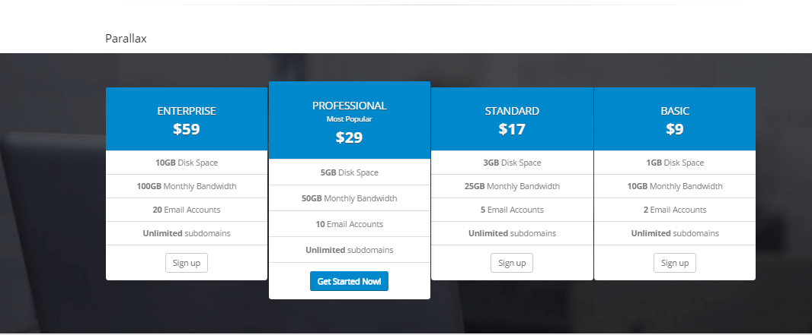

There will be HTMl part under this

# GRDJE

<https://www.journals.elsevier.com/academic-pediatrics/>

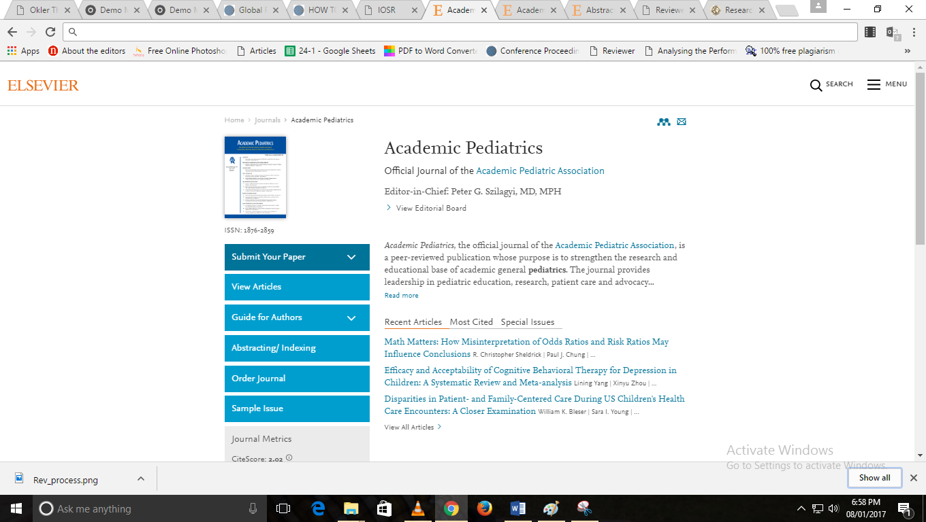

Follow this for it

Side menus will be

1. Submit article
2. About Journal
3. Research areas
4. Quality Reports
5. Journal Statistics
6. Processing Charges